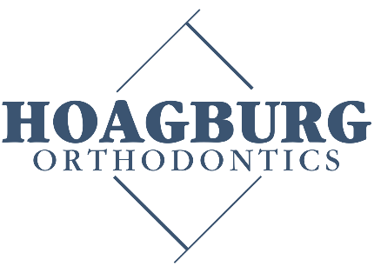
Dr. Brian Hoagburg, DDS, MSD
Dr. Rachel Hoagburg, DMD, MSD

Hoagburg Orthodontics Scholarship Application
A $1000 Scholarship will be awarded to one graduating high school senior that has been treated in the past or is currently in treatment with Dr. Hoagburg. This completed application, a senior picture along with a one-page essay on how orthodontic treatment has impacted the applicant’s life must be turned in to our office by June 30th, 2026. This $1000 scholarship must be used for the fall term following graduation and when notification has been received that the recipient has enrolled, it will be forwarded to the financial office of the intended college.
Name: ______________________________________ DOB: _________________________________
Address: ____________________________________________________________________________
Phone: ______________________________________ E-Mail:________________________________
Current Grade Point Average and Class Rank: __________________________________________
List all school and community activities: ____________________________________________________________________________________________________________________________________________________________________________________________________________________________________________________________________________________________________________________________________________________
College you plan to attend: ___________________________________________________________
Signature: _________________________________________________ Date: ____________________
Application should be forwarded to: INFO@HOAGBURGORTHO.COM

Photo should be submitted as .jpg, .png, or .pdf , Essay should be submitted as a .pdf

*All photos submitted with the application may be used by our office to display *

